

**Model: AQUATRACK-1**

**User Manual**

|  |
| --- |
| Please read carefully the present User Manual and apply **AQUATRACK-1** in strict compliance with the provisions and recommendations provided herein |

Dear Customer, thank you for buying **AQUATRACK-1**! We hope you will find this pioneer product very useful both for your indoor and outdoor purposes.

**Scope of application**

**AQUATRACK-1** is intended for advanced drinking water recovery treatment of water from superficial and underground raw water resources as well as from centralized water supply systems.

Application of **AQUATRACK-1** reduces to zero or to an acceptable rate the concentration in water of the following dangerous components:

- **malignant bacterium;**

**- heavy metals;**

**- pesticides;**

**- other hazardous substances.**

At the same time all important for human health micro elements remain preserved in the treated water.

**Design**

The track membrane cartridge is the core **AQUATRACK-1** element. The track membrane is a thin polymer film of about 10 microns thick, on each square centimeter of which there are hundreds of millions of pores (holes) of 0.2 or 0.4 microns in diameter (approximately 1000 times thinner than a human hair!), which ensures the highest quality of water purification.

The purification quality remains unchanged and does not reduce its perfectness until the complete expire of AQUATRACK-1 operating capacity.

AQUATRACK-1 is made of materials approved for contact with drinking water, the migration rate of any substances from AQUATRACK-1 materials into the processing water does not exceed established norms.

During purification the risk of mixture of purified and contaminated water is practically excluded due to the special design of AQUATRACK-1.

AQUATRACK-1 is very easy and convenient to use at home, and it is particularly indispensable outdoors (travelling, fishing, hunting, expedition), as well as in emergency situations.

**Purification Performance**

|  |  |
| --- | --- |
| **Contaminants** | **Purification level, up to** |
| Bacteria (cholera vibrio, coli bacillus and salmonella) | 99,9% |
| Pesticides | 99,9% |
| Iron (total) | 85% |
| Colority | 80% |
| Turbidness | 90% |

**Technical Characteristics.**

|  |  |
| --- | --- |
| Dimensions, mm (with bag) | 225х70х6 |
| Weight, gram | 130 |
| Operating temperature range, С0 | 4 – 40 |
| Capacity, liters | 18000* |
| Productivity, max, l/hour | 5 |

* AQUATRACK-1 capacity may reduce with time due to highly contaminated raw water. In such cases it is recommended to settle raw water for some time prior to AQUATRACK-1 treatment.

**Delivery Set**

|  |  |  |
| --- | --- | --- |
| 1. | Сartridge with outlet tube assembled | 1 unit |
| 2. | Case for storage and transportation | 1 unit |
| 3. | Tube plug | 1 unit |
| 4. | User Manual | 1 unit |

**Structure**

AQUATRACK-1 (1) is a track membrane located inside a soft bag which serves as an external preliminary filtering bag ( the bag retains mechanical particles, ooze, tangle, etc). The track membrane located inside the external bag is welded up along its perimeter and fitted with a coupling for release of the recovered drinking water through the soft outlet tube (2) connected to the coupling. The track membrane is wrapped around a metallic stainless frame. The frame provides rigidity to the cartridge and keeps it immersed in water in vertical position.

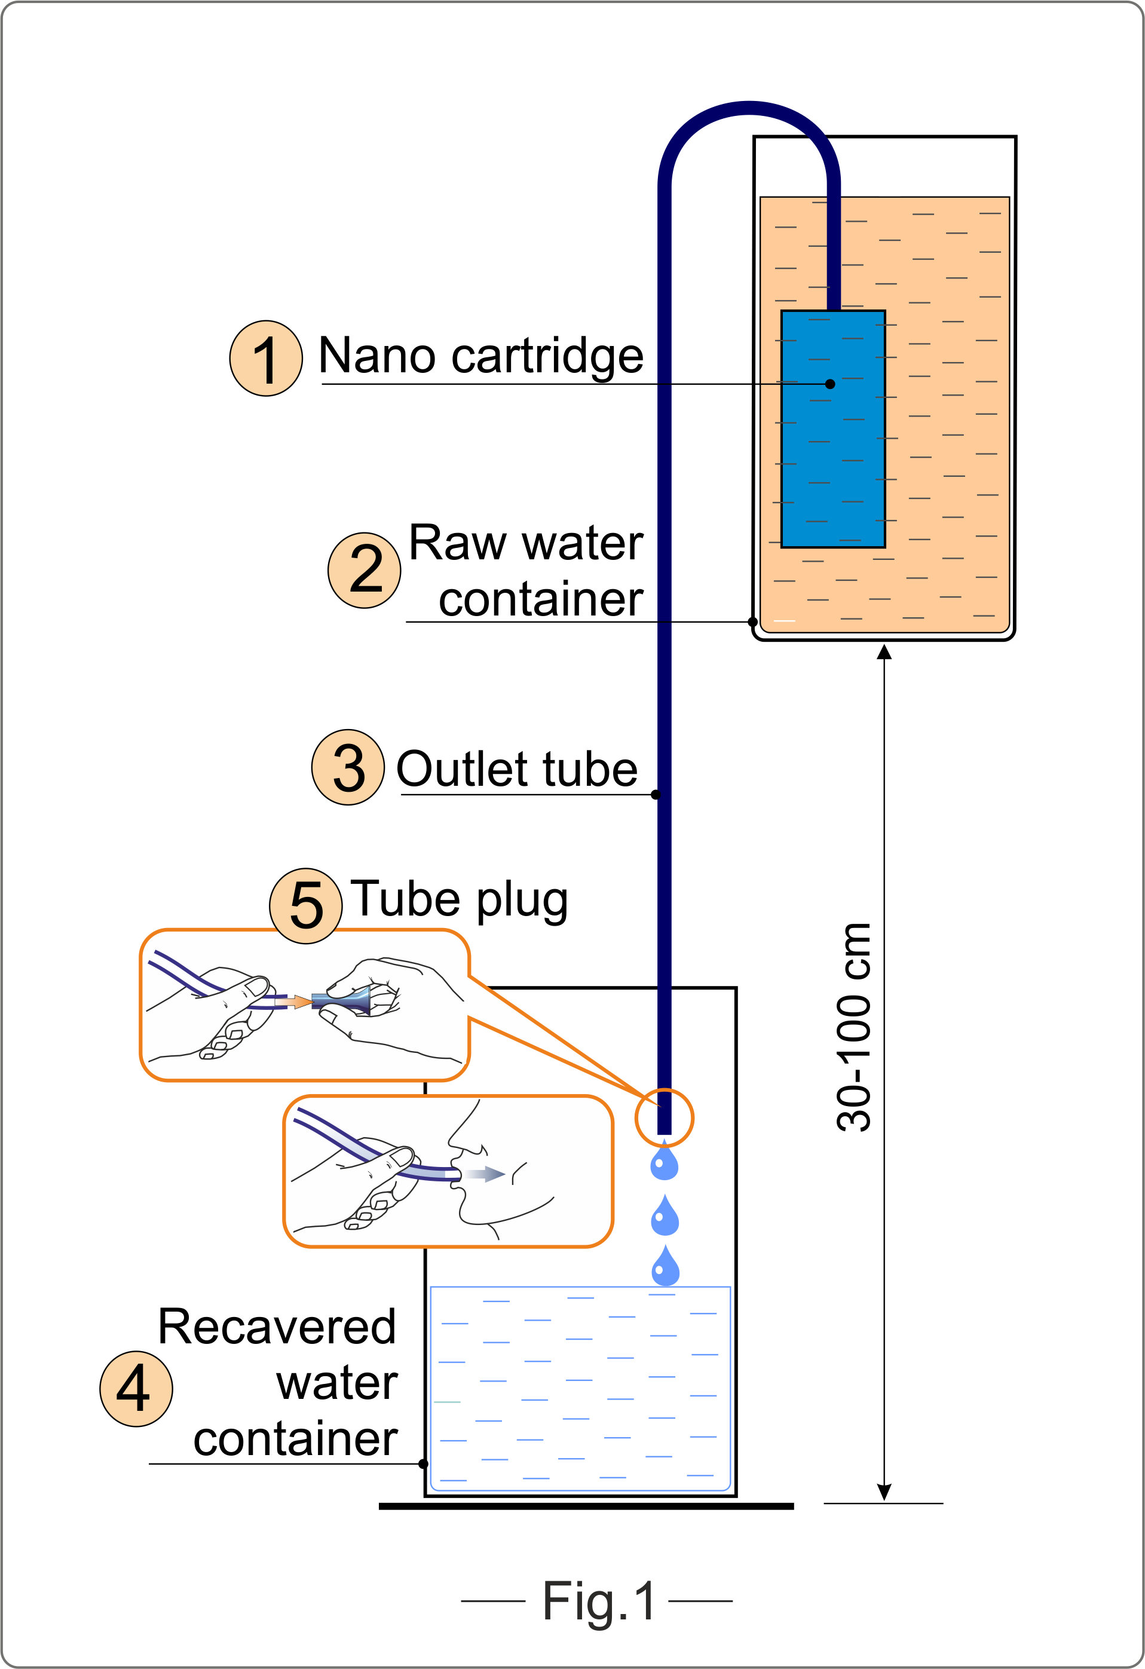

AQUATRACK-1 OPERATION STEPS (Fig.1)

**Attention**: DO NOT FORGET TO REMOVE THE TUBE PLUG (5) FROM THE OUTLET TUBE (3) BEFORE USE AND TO PLACE IT BACK AFTER USE!

**NAQWA® SWR operation is very easy and includes the following 6 simple steps:**

1. Prepare a container for recovered drinking water (4) (a drinking water vessel, a plastic bottle with a cut top, a suitable package, etc.).
2. Fill the raw water container (2) with raw water and locate it 30-100 cm higher than the container for recovered drinking water (4).
3. Take AQUATRACK-1 out of the transportation case and remove the tube plug (5) from the outlet tube (3).
4. Immerse AQUATRACK-1 cartridge (1) into the raw water container (2), keeping the free end of the outlet pipe (3) off the container.
5. Lightly suck the air out of the outlet tube, the purification process will start within 5 seconds. If the air is not sucked out of the outlet tube the cartridge will get soaked up with raw water by itself and the purification process will begin in 10-15 minutes.
6. Place the free end of the outlet tube into the container for he recovered drinking water (4).

**Note.** At the beginning the recovered drinking water will flow as a current the intensity of which will decrease with time and after a while AQUATRACK-1 will start operating in the normal “drop-by-drop” mode.

**Maintenance**

AQUATRACK-1 cartridge should be cleaned in case of visual slow down of its productivity. In order to do that, remove the track membrane cartridge from the outer pre-filter bag, open it and thoroughly rinse under water current. Contamination on the membrane surface should be gently removed with a soft tissue, for instance PU foam.

**Please do not overpress on the membrane as you may damage it!**

For the most effective cartridge restoration soak the cartridge in 5-7% citric acid solution and leave it in it for 1-2 hours. Afterwards flash the cartridge surface with clean water. Another effective method of cartridge treatment is its cleaning in weakly alkaline environment with further subsequent rinsing under water current. In the latter case dishwashing alkaline-based detergents can be used. After cleaning, assemble the cartridge in the reverse order.

It is recommended not to use the first 0.5-1.0 liters of water recovered after cartridge cleaning in alkaline solutions.

**Attention!**

- During cleaning do not disconnect the outlet tube from the coupling which connects the tube to the cartridge;

- Prevent invasion of raw water and detergents inside the track membrane. For this reason it is recommended to plug the free end of the outlet tube with the tube plug provided.

**Operation Guide**

1. During the operation, do not locate AQUATRACK-1 exposed to direct sun light.

2. In case of a long break in operation for more than 5 days, remove the track membrane cartridge from the bag, wash, dry and store it in a clean place having closed the outlet tube with the tube plug.

3. In case of a short break in operation for 2-5 days it is recommended to keep the cartridge in water, hanging the free end of the outlet tube at the edge of the raw water container, however not dropping it into the container.

**Attention!**

To avoid any damages to the track membrane the following actions should be avoided:

- usage of AQUATRACK-1 for other purposes rather then drinking water recovery;

- back - blowing the cartridge filter through the outlet tube;

- wiping the cartridge with rigid materials, brushing the cartridge;

- connecting the outlet tube to pressurized water pipeline.

**Storage**

AQUATRACK-1 should be stored inside the supplied consumer package in a dry place at temperature of 5-400С.

Do not store AQUATRACK-1 outside the package case.

**Warranty**

The Manufacturer warranties successful performance of AQUATRACK-1 within 12 months after the date of purchase provided the storage, installation, and operation regulations specified in the present User Manual have been observed.

Warranted shelf storage term before commencement of operation is 5 years from the manufacturing date.

During the warranty term, the Manufacturer undertakes to repair or replace defective parts of AQUATRACK-1 free of charge provided AQUATRACK-1 malfunctioning occurs through the fault of the Manufacturer.

AQUATRACK-1 replacement will be done only upon submission to the Manufacturer of the present User Manual with the marked date of purchase as well as the seal and signature of the seller.

No claims shall be accepted in case of any mechanical or other damage caused to AQUATRACK-1 after it sale, as well as in case of violation of the regulations specified in the present User Manual.

## Compliance Statement

AQUATRACK-1 fully corresponds to the Technical Requirements and is ready for operation.

Certificate of compliance No № C-RU.HO03.B.00467 of 22.11.2012 г

Date of issue__________ Producer REATRACK-Filter Ltd

Batch number__________ 249030, Obninsk City, Kaluzhskaya Area, Russia.

reatrack@mail.ru

www.reatrack.ru